Technical Architecture:

Project Design Phase-II Technology Stack (Architecture & Stack)

|  |  |
| --- | --- |
| Date | 15 October 2022 |
| Team ID | PNT2022TMID42037 |
| Project Name | Efficient Water Quality Analysis and Prediction using Machine Learning |
| Maximum Marks | 4 Marks |

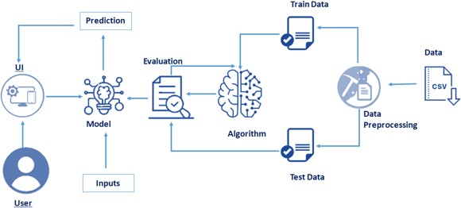

Table-1 : Components & Technologies:

|  |  |  |  |
| --- | --- | --- | --- |
| **S.NO** | **Component** | **Description** | **Technology** |
| 1. | User Interface | How user interacts with application e.g. Web UI, Mobile App, Chatbot etc. | HTML, CSS, Python |
| 2. | Application Logic-1 | Logic for a process in the application | ML Algorithms. |
| 3. | Application Logic-2 | Logic for a process in the application | IBM Watson STT service |
| 4. | Dataset | Data Type, Configurations etc. | Dataset used for this project is downloaded from Kaggle. |
| 5. | Cloud Database | Database Service on Cloud | IBM DB2, IBM Cloudnet etc. |
| 6. | File Storage | File storage requirements | IBM Block Storage or Other Storage  Service or Local Filesystem |
| 7. | Machine Learning Model | Purpose of Machine Learning Model | Classification and Regression model |
| 8. | Infrastructure (Server / Cloud) | Application Deployment on Local System / Cloud Local Server Configuration:  Cloud Server Configuration : | Local, Cloud Foundry, Kubernetes, etc. |

Table-2: Application Characteristics:

|  |  |  |  |
| --- | --- | --- | --- |
| **S.NO** | **Characteristics** | **Description** | **Technology** |
| 1. | Scalable Architecture | Water quality index (WQI) and water quality Classification (WQC) are accurately predicted. | Surface water quality assessment tool will be used here |
| 2. | Availability | Our model will keep working and be available for work even if there is infrastructure failure. | Machine learning |
| 3. | Performance | The system effectively compares the input parameters given by the users with the dataset | Digital twin technology |